Practical-11
Student Management CRUD with Search and Filter
Theory
1. Are SELECT, INSERT, UPDATE, and DELETE operations working?
Answer: SELECT, INSERT and UPDATE were demonstrated successfully using the Student Directory. A new record increased the count from 40 to 41, and updating its city was confirmed. DELETE was not included in the verified test results.
2. Is search by name/email/course implemented?
Answer: The Student Directory provides a search box for name, email, course or enrollment ID. Searching for "Test Student" returned one matching student. The B.Tech CE course filter displayed 17 matching active students. Separate email-only searching was not captured.
3. Are delete operations confirmed before execution?
Answer: A Delete action is available in the student table. The confirmation-dialog test was not captured, so it is not reported as verified in this practical.
Result:
A PHP-MySQLi student management module was demonstrated in StudentHub. Student records were displayed with pagination; a new student was inserted, an existing record was updated, searching by name and filtering by course returned matching results, and the active student list was exported to CSV. The screenshots document these completed tests.
Evidence of Work (Screenshots)
The following original screenshots document the SQL import, admin student directory, tested CRUD operations, search, filtering and CSV export. Only verified actions are included.

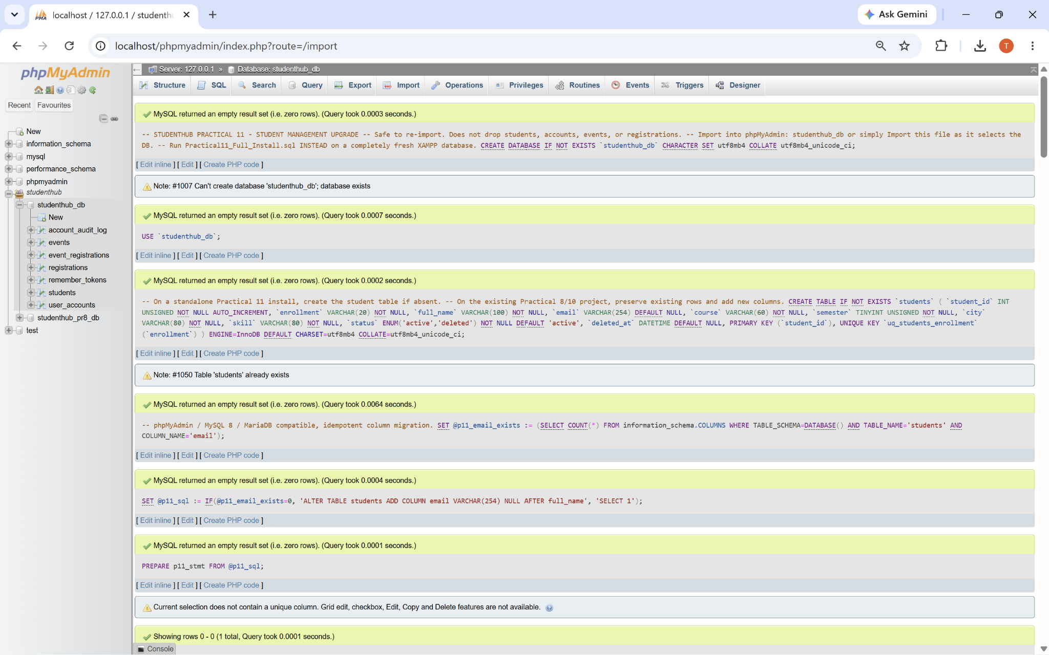
Figure 1: Practical 11 SQL Upgrade - phpMyAdmin Import Output
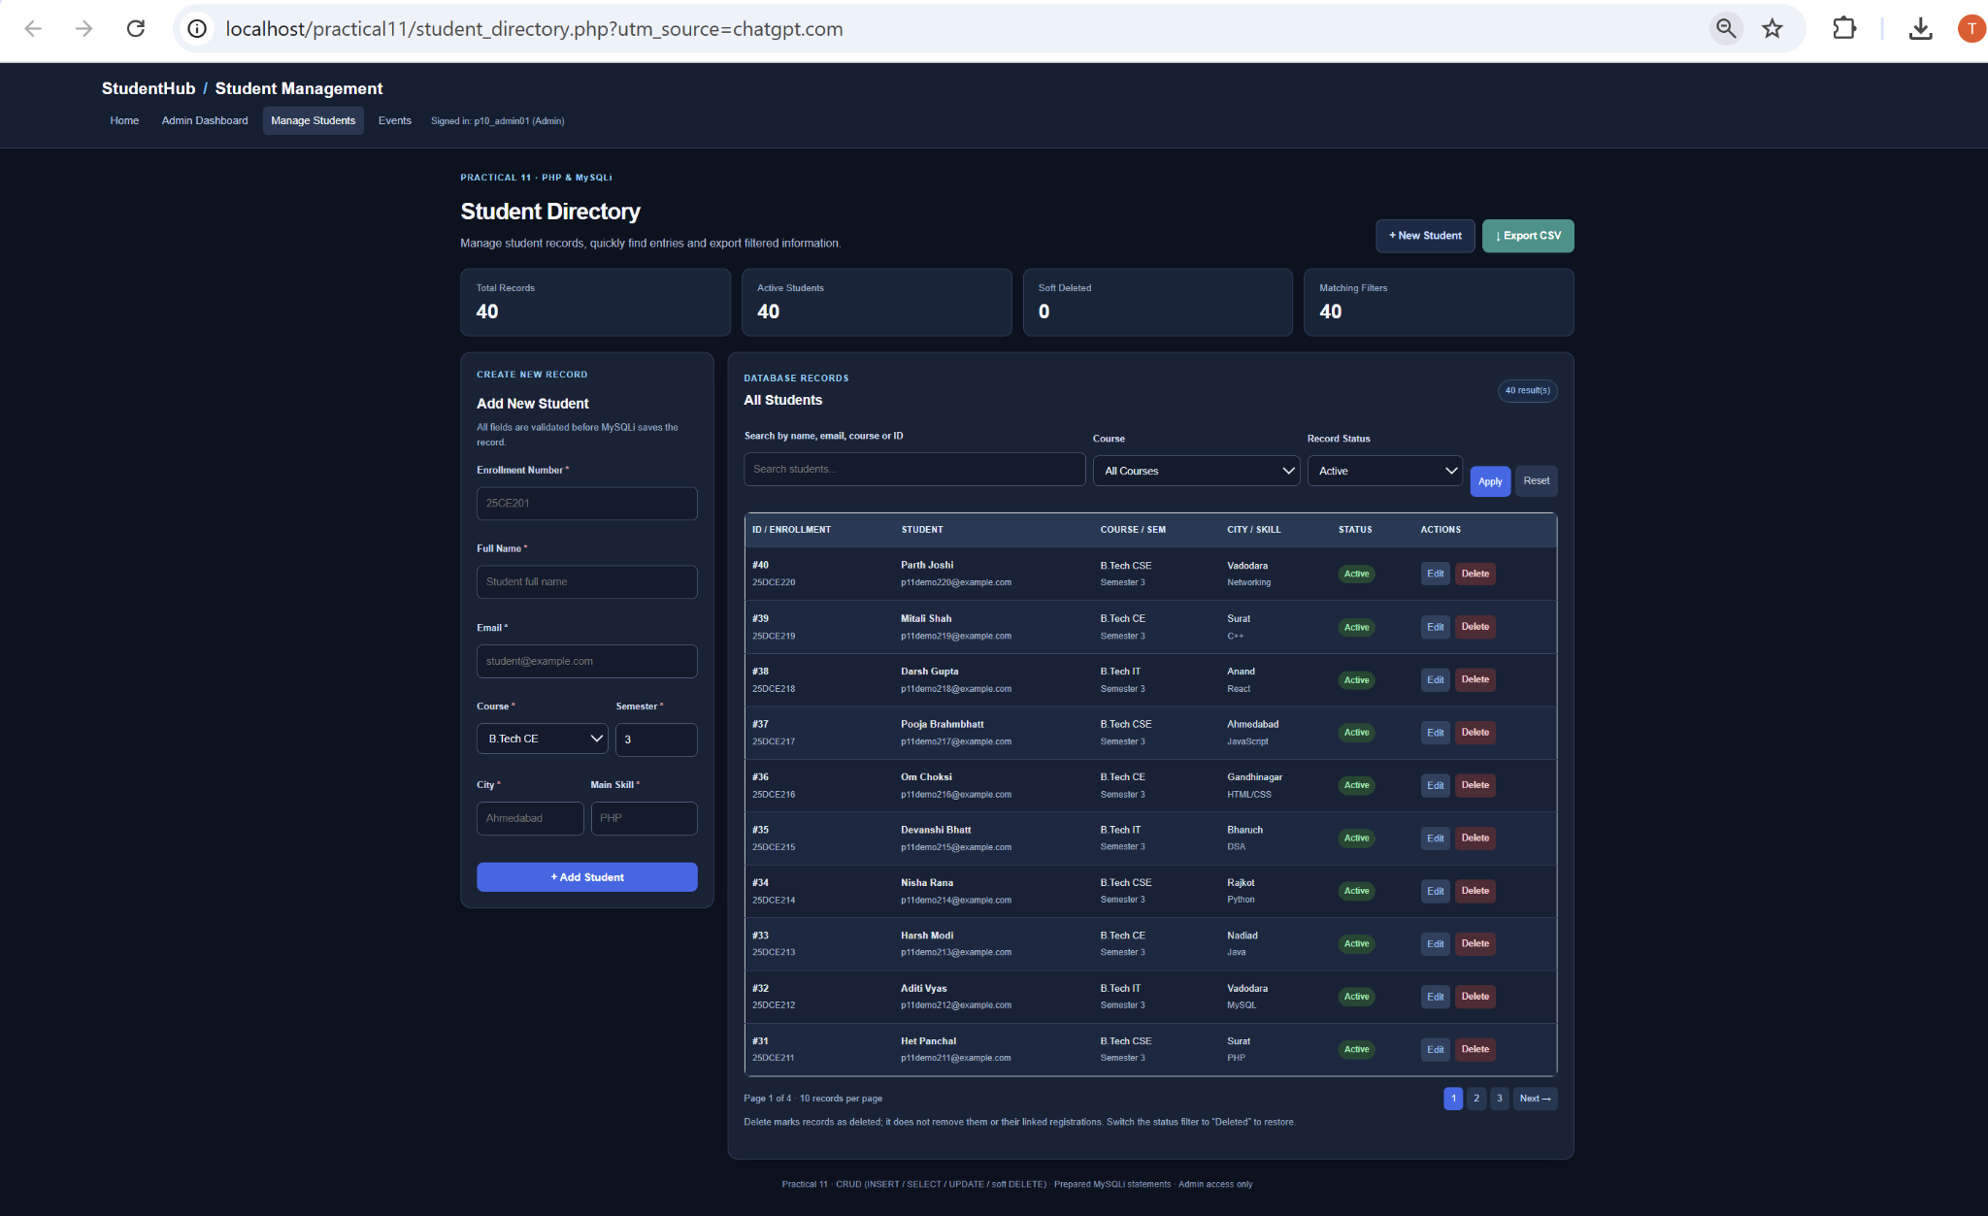
Figure 2: Student Management Dashboard - 40 Records and Pagination

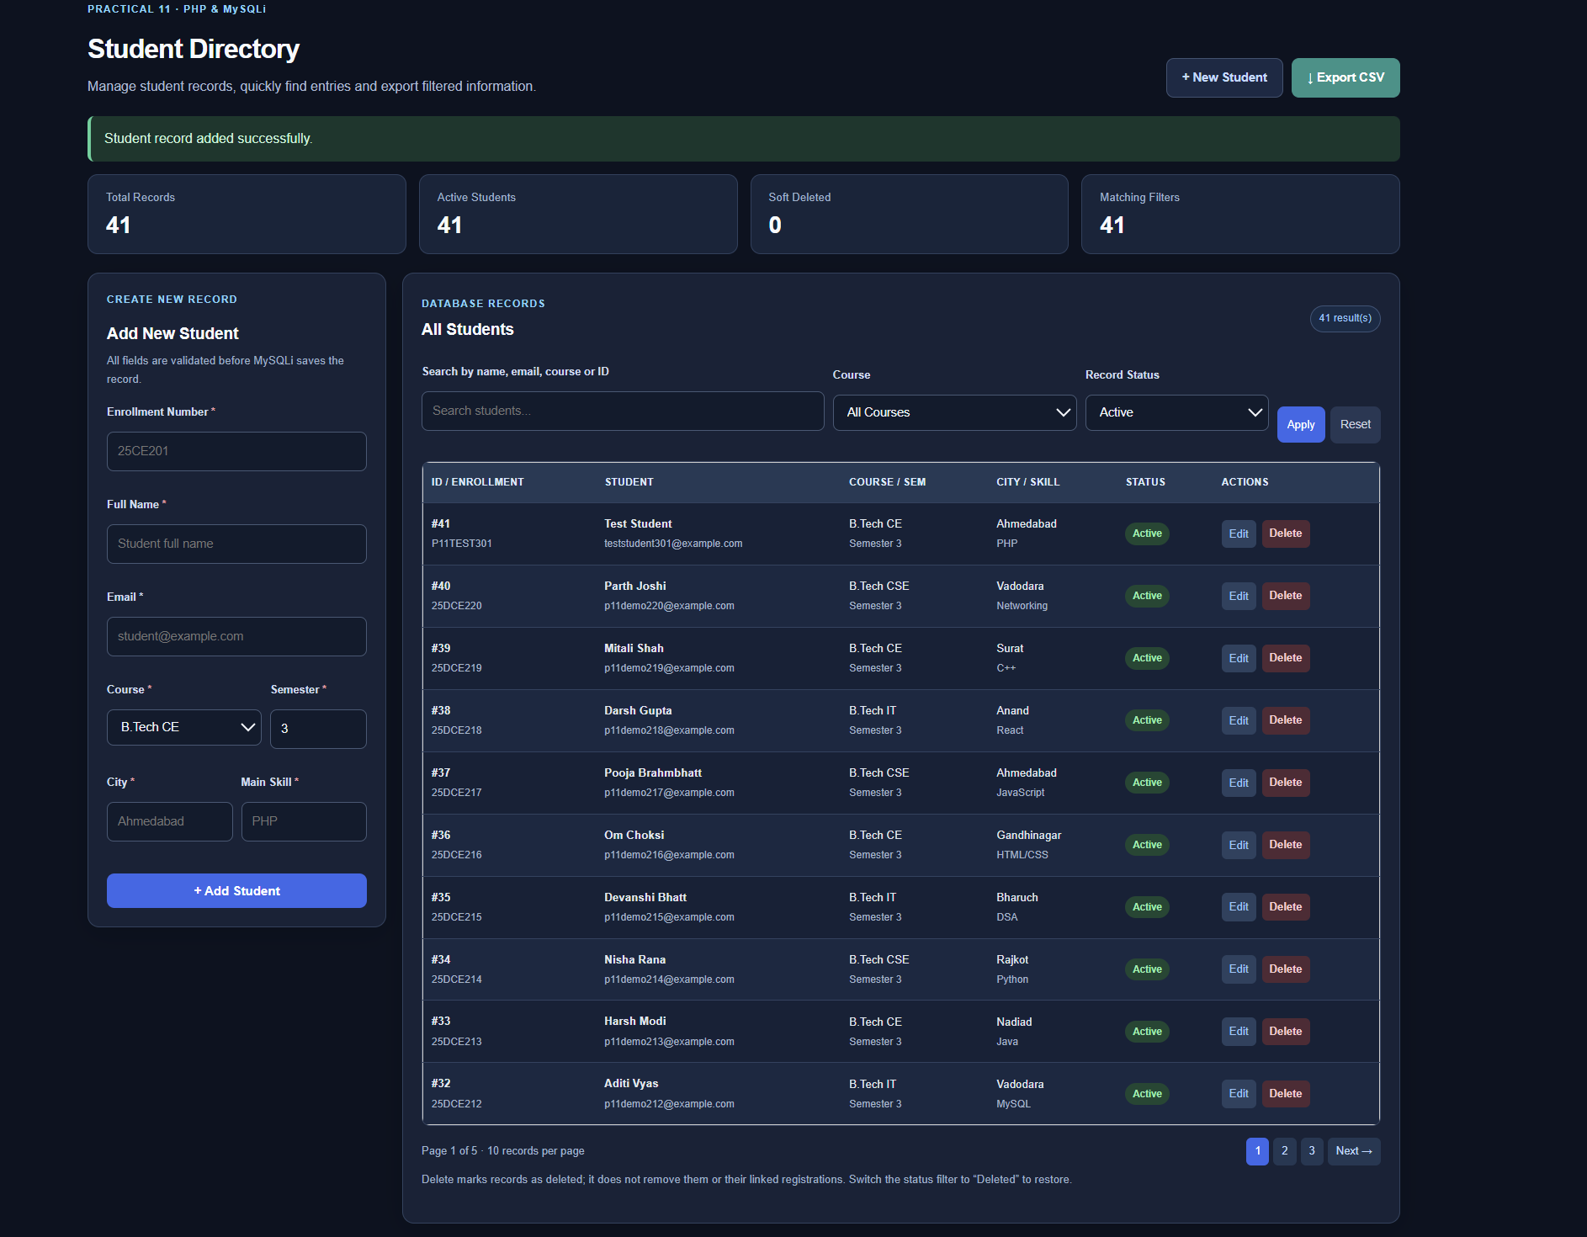
Figure 3: New Student Record Added Successfully - 41 Records
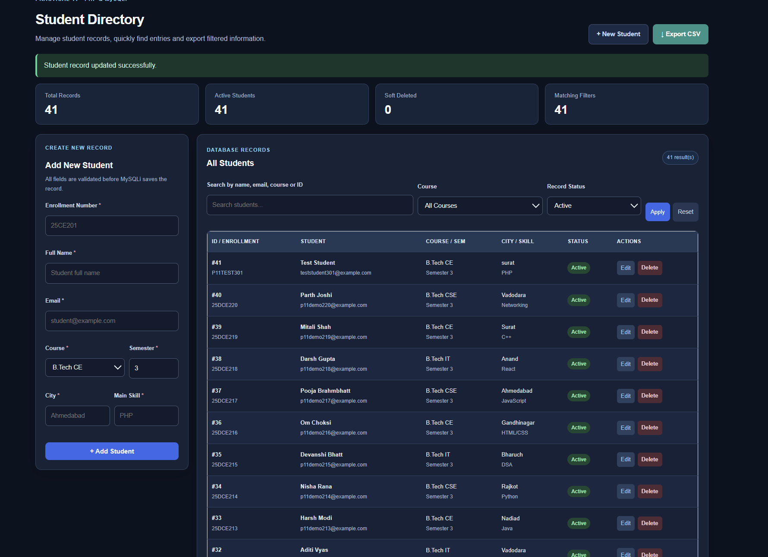
Figure 4: Student Record Updated Successfully - City Changed

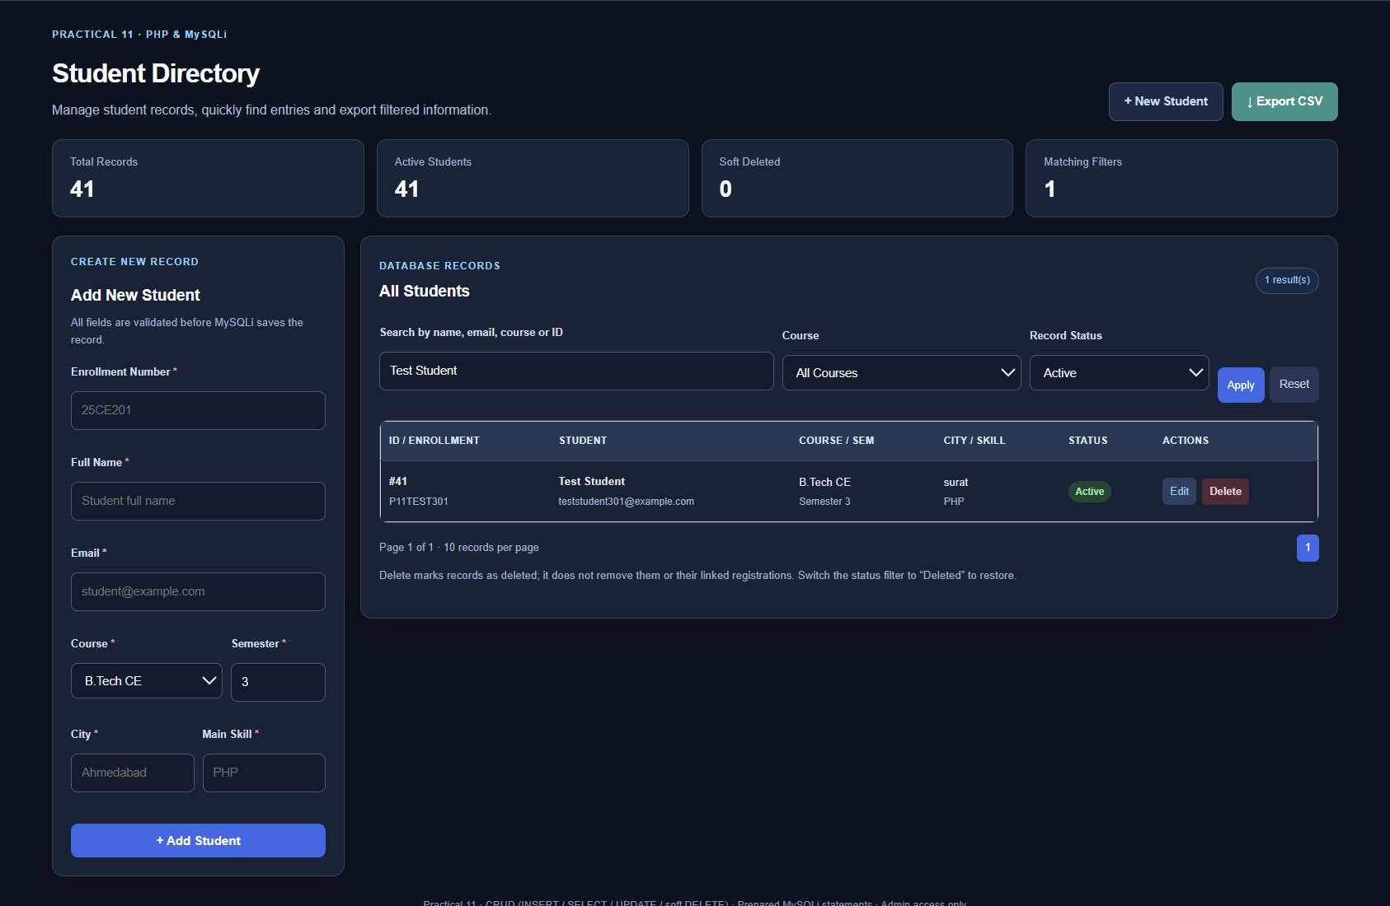
Figure 5: Student Search by Name - One Matching Record
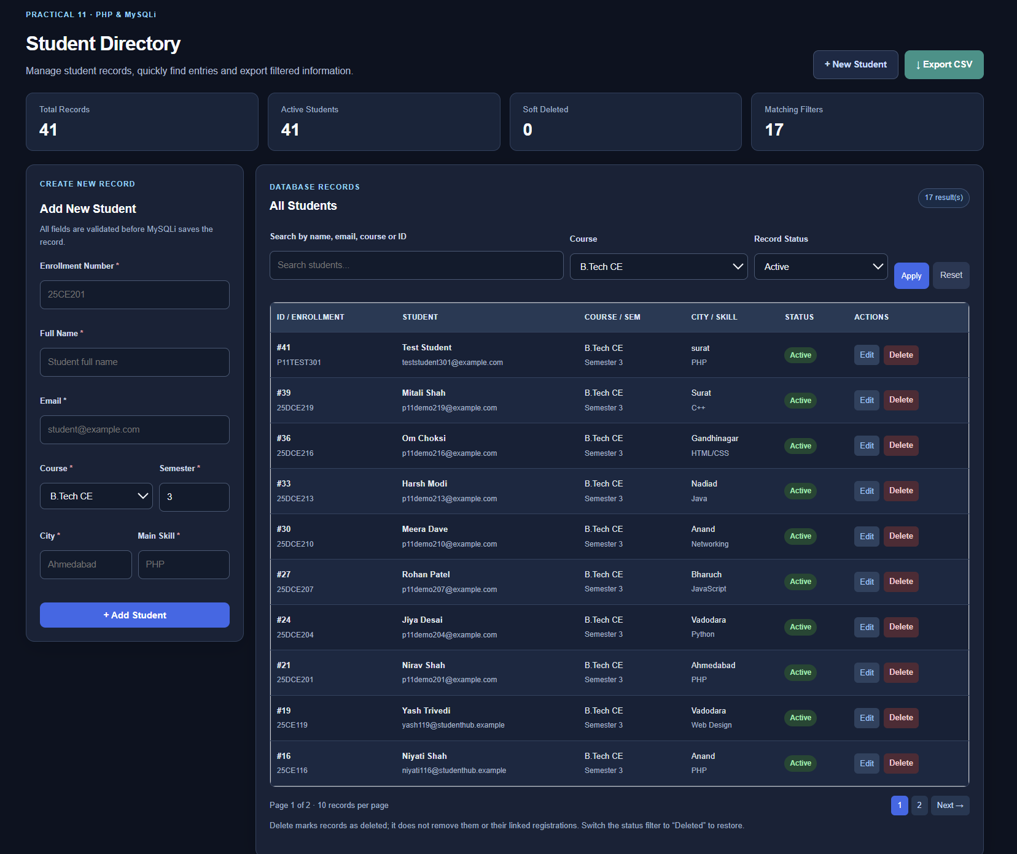
Figure 6: Course Filter - B.Tech CE Students (17 Matches)

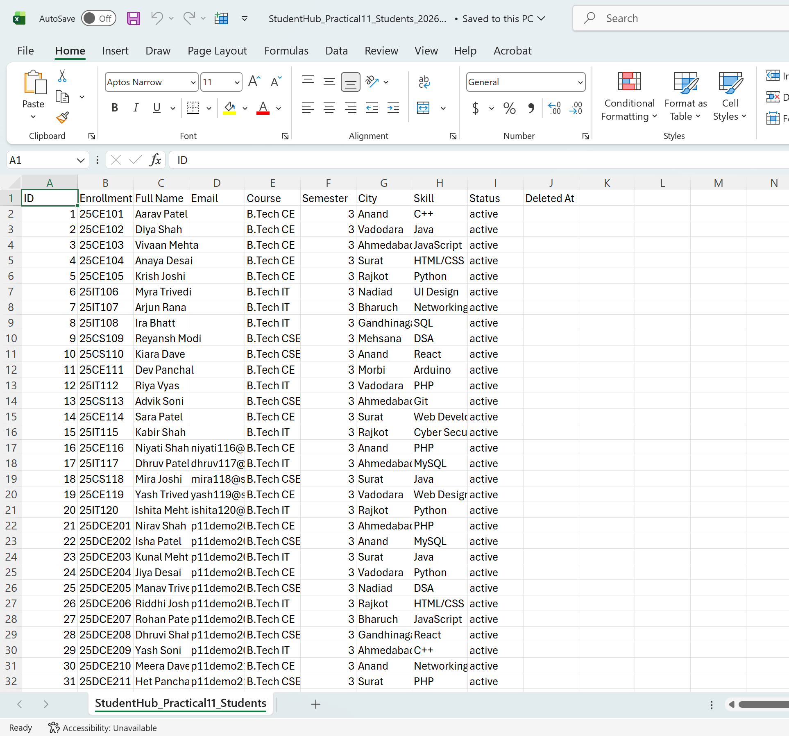
Figure 7: Student Records Exported to CSV and Opened in Excel
The exported sheet shows fields including ID, Enrollment, Full Name, Email, Course, Semester, City, Skill, Status and Deleted At.

A. GitHub Repository Link:
https://github.com/adrojatarang8-art/StudentHub
B. Challenges Faced:
• I corrected a 404 page-path issue by placing the project inside the practical11 folder under XAMPP htdocs.
• I imported the Practical 11 SQL upgrade into the existing studenthub_db without deleting the existing student records.
• I tested insertion and editing, then used search and course filters to locate the required records.
• I exported the student list to CSV and opened it in Excel to inspect the generated columns.
C. Learning Outcome:-
I learned to manage student records using PHP, MySQLi and a database-driven interface. I practiced inserting and updating student information, displaying records with pagination, searching by name, filtering by course and exporting records to CSV. I also learned to verify each completed operation using browser and database evidence.
Faculty Remarks:

